Summer Playscheme
LANE END’S

Lane End Youth & Community Centre, Edmonds Rd, Lane End, HP14 3EJ
Mon 7th , Tues 8th, Wed 9th Aug - Trip out
Mon 14th, Tues 15th, Wed 16th Aug
10am – 3pm
£15 per day
(£20 on trip day – 09.08.23)
FREE PLACES AVAILABLE, FUNDED BY BUCKS WITH A UNIQUE HAF CODE

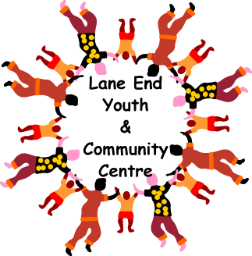
For Children age 5 – 12 years old
Snack, drinks and hot lunch provided everyday

