Lane End Youth & Community Centre

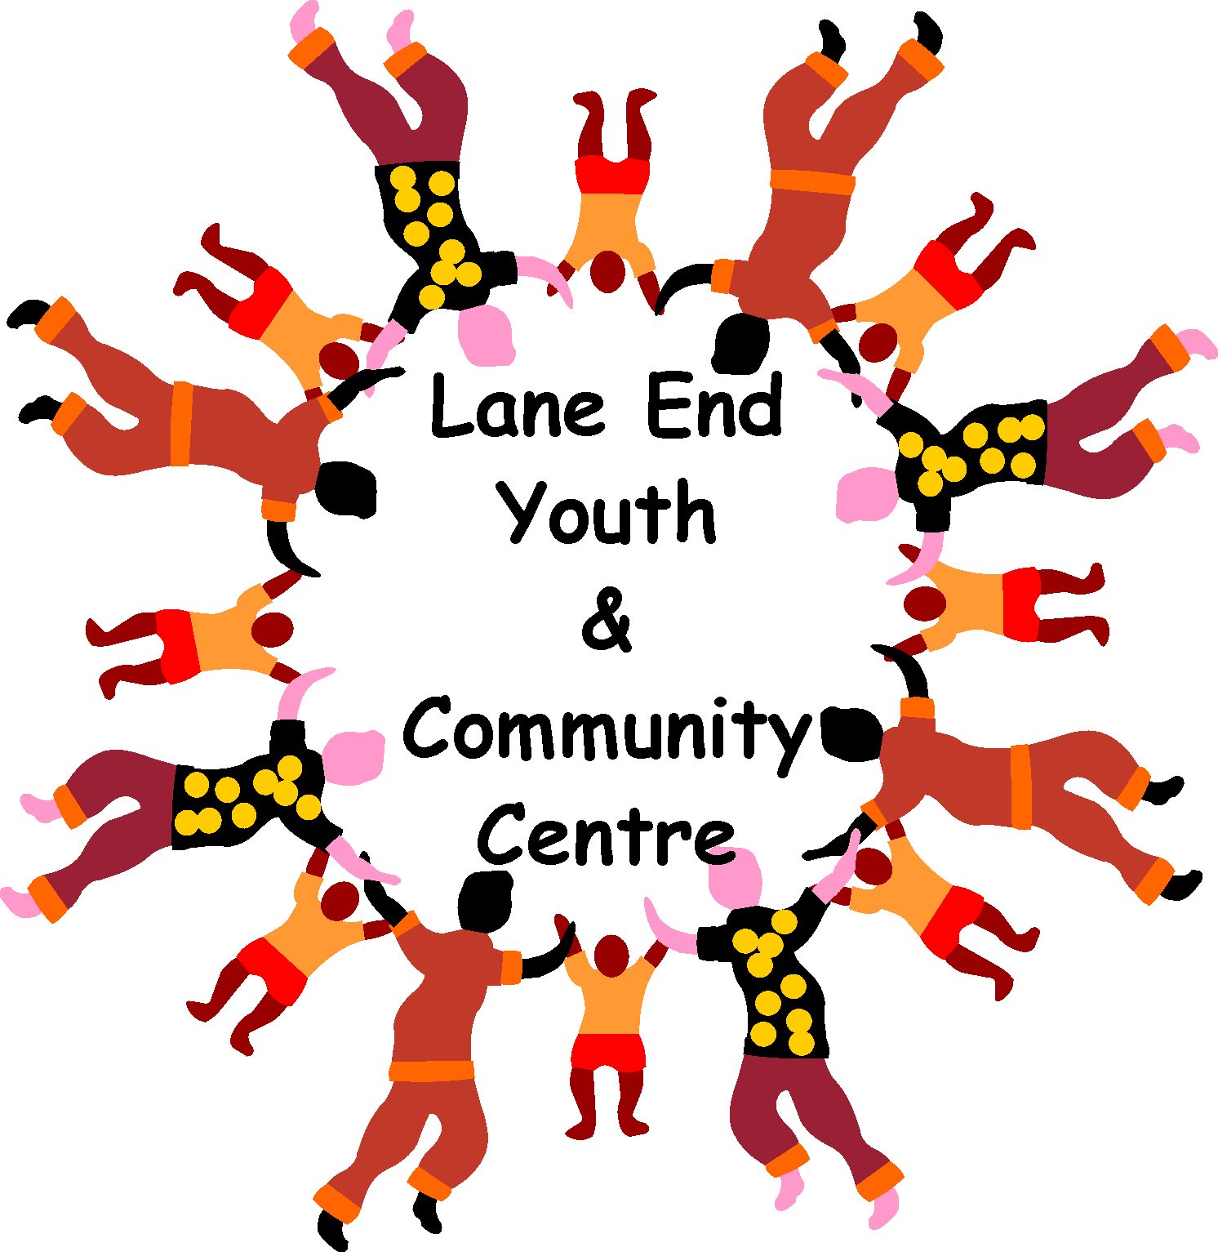

Lane End Youth & Community Centre, Edmonds Road, Lane End, High Wycombe, HP14 3EJ

T: 01494 883878 M: 07932 326046 E: leycc@hotmail.co.uk

Charity Number: 1101360

www.leycc.co.uk

Report by Emma Savory
This Spring at the Centre…

February – ½ term Playcheme is back on TUESDAY 14th FEB,
10am – 3pm, £15 per child (Primary age children )

April – Easter Playcheme on TUESDAY 4th & 11th APRIL
10am – 3pm,
(Primary age children )

DROP IN’S AFTERNOON TEA
THURSDAY 13th APRIL
12.30pm
£8.00 pp – booking essential

- Coffee Morning – Monday 10am –12noon
- Gentle exercise – Monday 2.30pm – 3.30pm
- Bedouin Breathwork – Monday 7.30pm join us to meditate and explore breathing techniques to help with stress relief and anxiety
- Self Defence with Ultra Krav Maga – Tuesday 7pm and Sunday 9am
- Junior Youth Club – Wednesday – 6 – 8pm
- Drop In Lunch Club - Thursday – 12noon
- ZUMBA GOLD with Jennifer Morais – Thursday 10.30 – 11.15am
- Lane End Food Bank – Friday 8.45am – 11am
- Dog Training – Saturday mornings with Bells and Whistles

Every Friday 8.45am – 11am
EVERYONE welcome
Take what you need or donate what you can
FREE refreshments
Lane End Youth & Community Centre

Having a party? - The Centre is so versatile and can be used for many different events/
Celebrations. Drop Emma an email at leycc@hotmail.co.uk to check availability and prices.
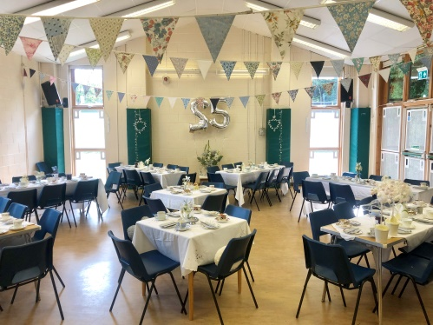

Please add ‘Lane End Youth & Community Centre’ on Facebook,
Remember the Centre is here for the community, please support it!

