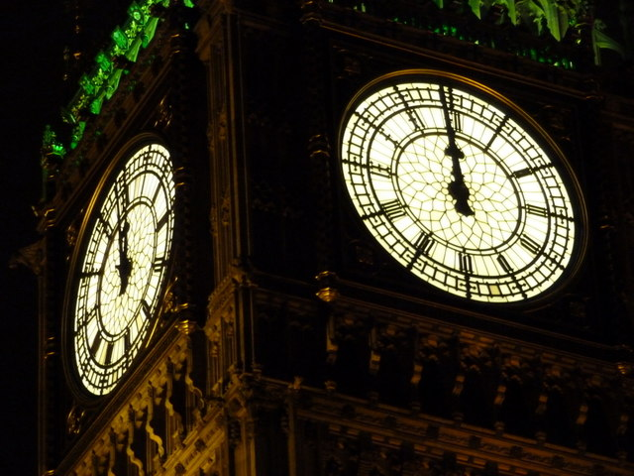
CELEBRATE THE NEW YEAR
2018

Come and celebrate the New Year with us at Lane End Youth & Community Centre. The party starts at 7pm. Bruce will provide the music. Just bring your own drinks and nibbles.
Tickets £7.50 per person
In advance from the Centre office.
Lane End Youth & Community Centre. Edmonds Road, Lane End, Bucks HP14 3EJ
01494 883878 leycc@hotmail.co.uk leycc.co.uk

