Lane End Youth & Community Centre
Charity Number: 1101360
www.leycc.co.uk
T: 01494 883878 E:leycc@hotmail.co.uk W: www.leycc.co.uk
Report by Emma Savory

WHAT’S ON AT THE COMMUNITY CENTRE

Thank you to all the local families who supported the Summer Playscheme, we had an absolute blast and the children especially enjoyed the visit from Mr Reptile Man, How to be a Spy workshop and the fun and games provided by Wayne Wonder. We love being able to provide child focussed activities to so many children and really appreciate our families loyalty, support, and grants/funding that we work so hard to achieve enabling us to provide such a varied enriched programme of activities at affordable prices.

Please join us at the Centre on Friday 28th September 2018, for the BIGGEST coffee morning! Come between 9am and 11am for tea/coffee and cake with your friends. Help us raise money for MacMillan Cancer Support. PLUS any cake donations would be greatly received.

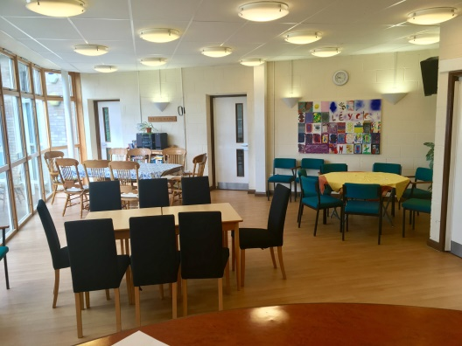
COOK/SERVER - Thursday Lunch Club 12 – 1.30pm
We are currently looking for people who can help, cook/serve at our lunch club, maybe you have 2 hours a month you can spare to help out? Every Thursday we welcome our older regulars into the Centre for a 2 course cooked dinner with tea or coffee for £5.50. If you would like to volunteer once a month please get in touch.

Coffee Shop – Mondays 10.30am – 12noon
Do you want to meet new local people? Then come along to our coffee morning, every Monday at 10am. All ages welcome.

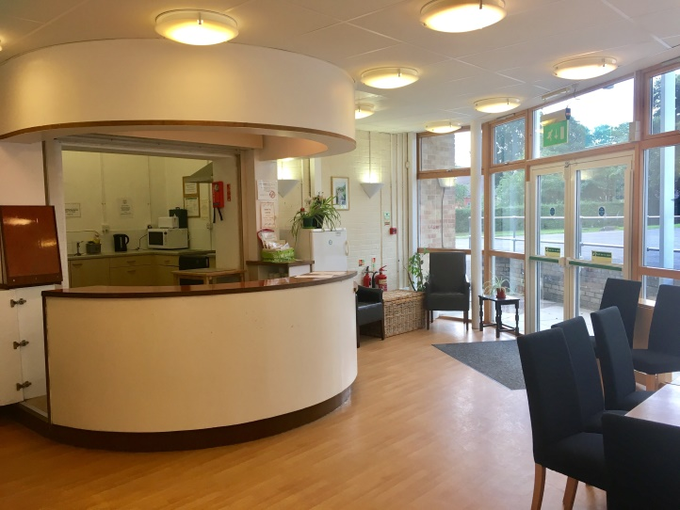
Having a party? - The Centre is so versatile and can be used for many different events/celebrations, we are very competitively priced, offering discounts to Lane End residents. Pop into the Centre or call anytime to check availability and prices for private hire

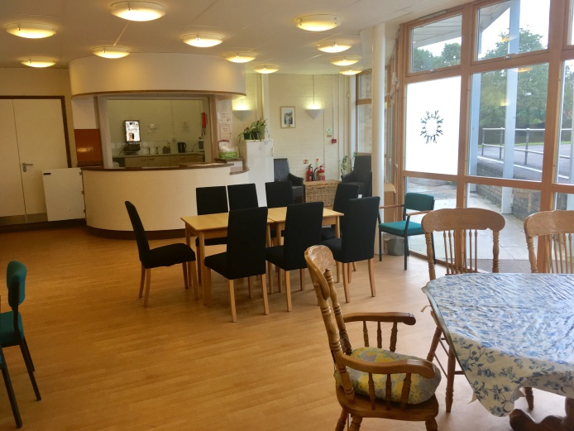

Please add ‘Lane End Youth & Community Centre’ on Facebook, ask to join the group and you will become one of the first to find out about all our latest events! Also check out our new website at www.leycc.co.uk
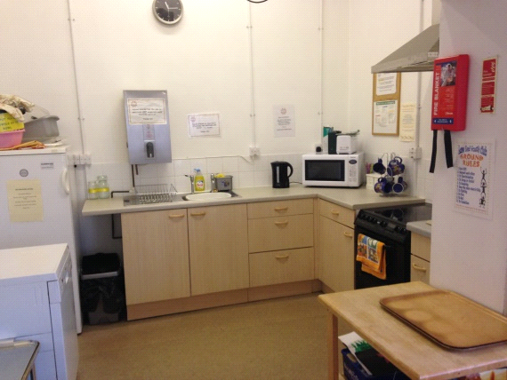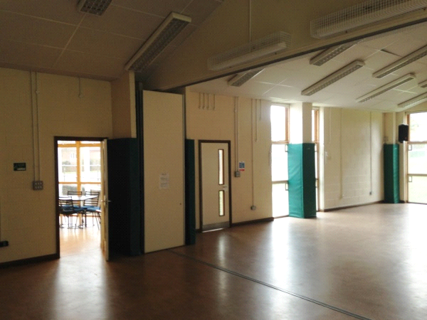
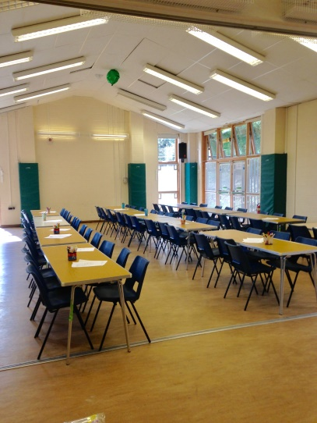

LANE END YOUTH & COMMUNITY CENTRE
T: 01494 883878 E:leycc@hotmail.co.uk W: www.leycc.co.uk

