Lane End Youth & Community Centre

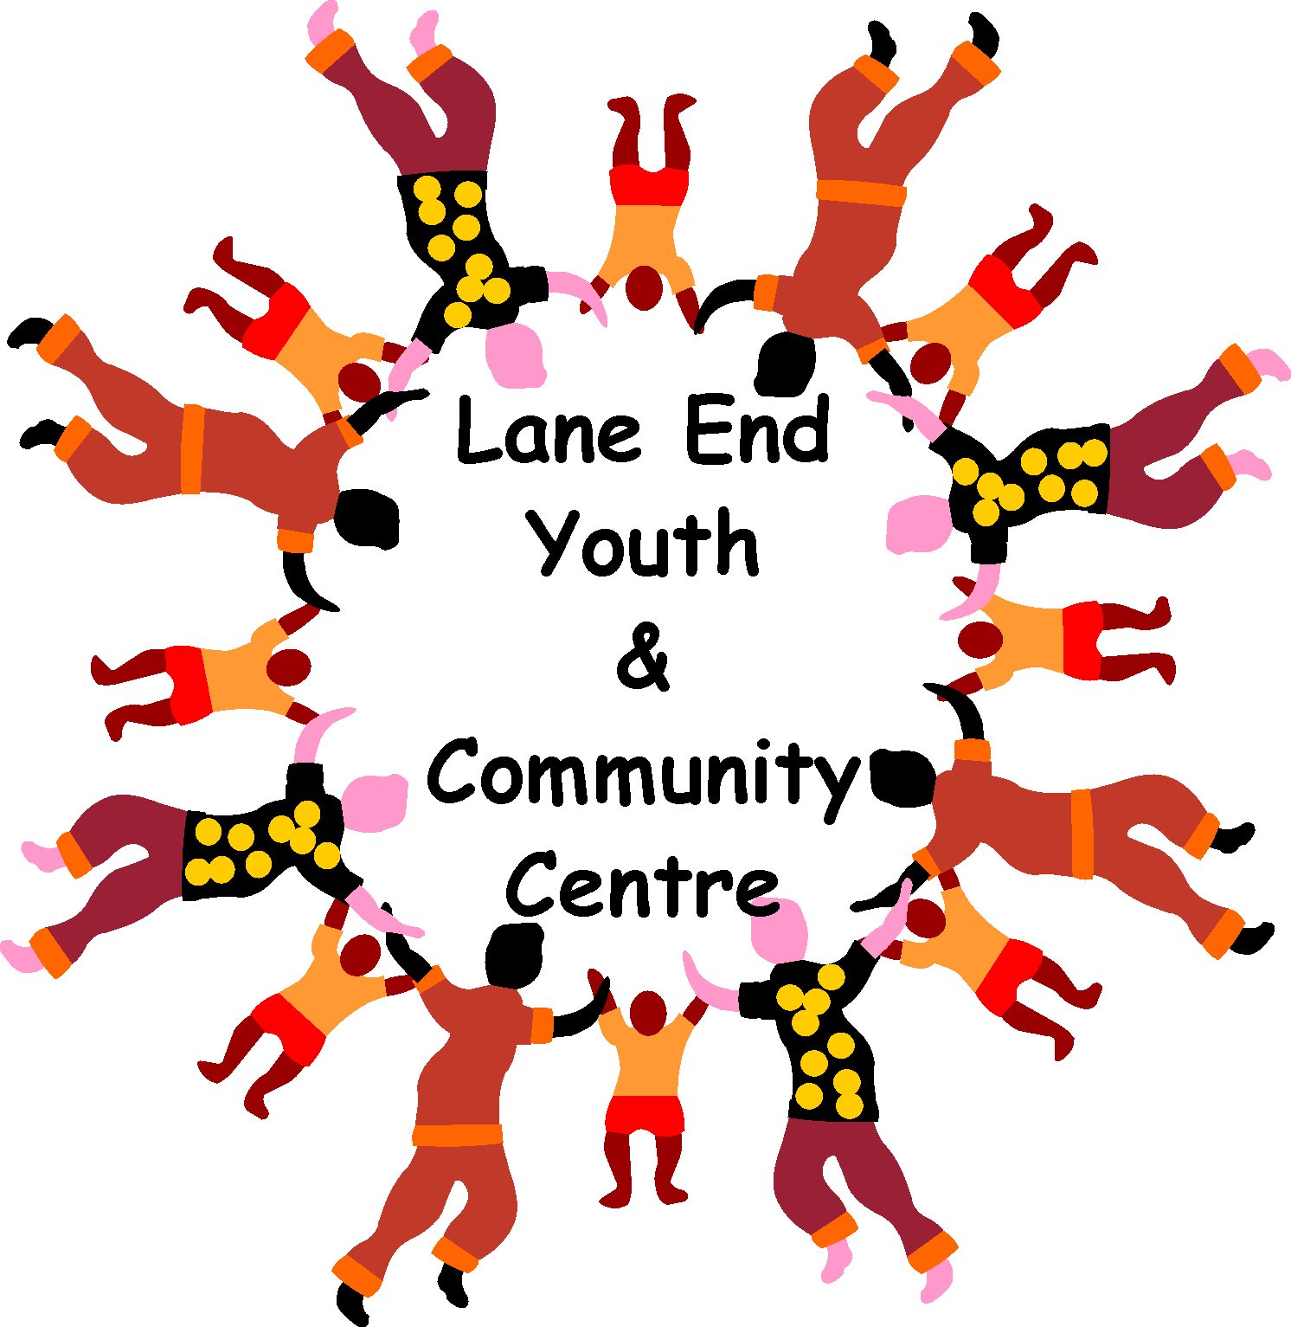

Charity Number: 1101360

www.leycc.co.uk

Report by Emma Savory
WHAT’S ON AT THE COMMUNITY CENTRE
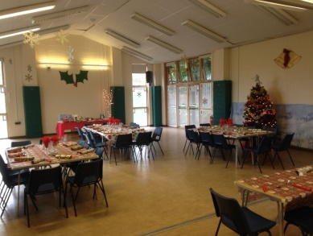

CHRISTMAS Thursday Lunch Club
Thursday 20th December 2018
The Centre is hosting our Christmas Lunch festivities for our regular lunch club members. This year it is on 20th December. You will be welcomed with a drink at 12.30pm. A traditional Christmas dinner with all the trimmings served at 1pm. Followed by a choice of pudding, plus tea/coffee and mince pies. All this for £8.50. Plus a little bit of light entertainment and a raffle. This Christmas lunch is available to our Thursday lunch regulars and anyone over 50 who will be on their own over Christmas. Places are to be booked and paid in advance.
New Years Eve
Sunday 31st December 2018
Join DJ Bruce for a disco on NYE, for the over 50’s. Bring your own drink and nibbles, plus some cash for a raffle. Tickets cost £7.50 and can be purchased from the Centre office.

**Opening hours over the Christmas period –**
Closed from Monday 24th December 2018 until Wednesday 2nd January 2019.
We would like to thank all our regular hirers and wonderful people who have supported the Centre throughout 2018, the Centre is here because of you and for everyone to use. We hope you continue to enjoy the facilities in 2019. On behalf of everyone at the Centre, I would like to wish you all a very Happy Christmas and a healthy New Year. .

GET INVOLVED
Could you spare a couple of hours every 6 – 8 weeks? Would you like to join our committee who meet (in a pub!) every two months to help organise events and discuss the running of the Community Centre? We would love to hear from you, please email Emma on leycc@hotmail.co.uk or call 883878.

DINNER AND DISCO – SATURDAY 16th FEBRUARY 2019
Sick of Valentines romance? Join us at the chequers Inn, Wheeler End who are hosting a fundraising evening for us on Saturday 16th February 2019, from 7pm til late. Enjoy great food and a disco, with friends, partner or both! Tickets are £20 and include a 2 course meal and a disco, we will also hold an auction or raffle on the night to help raise funds for the Centre. Tickets to be purchased in advance from the Community Centre office.
Not sure what we offer, take a look at our weekly schedule ………………

Mondays: | 10.30am–12.00pm | ‘Drop In’ Coffee morning – All welcome
 | 2.00pm–3.00pm | Gentle Exercise for the over 50’s  Karen - 07702498924
 | 6.00pm–8.00pm | Pilates with Lauren Fois 07709430634
Tuesdays: | Daytime available for hire
 | 7.25pm – 8.25pm | NEW PILATES fusion Nicky - 07378338803
Wednesdays | Daytime available for hire
 | 6.00pm–8.00pm | NEW Youth Club - 07759540921
Thursdays:
 | 12.00pm–1.30pm | The Drop-in Lunch - 883878
 | 2.00pm–4.00pm | 1st Thurs of the month – LEAOPAG
 | 7.30pm–10.00pm | Soundforce Big Band Rehearsal
Fridays: | 9.30am–10.30am | Circuit Training - 07884154081
Saturdays | 9.00am–12.00pm | Bells and Whistles dog training - 07703020344
WEEKENDS AVAILABLE FOR HIRE

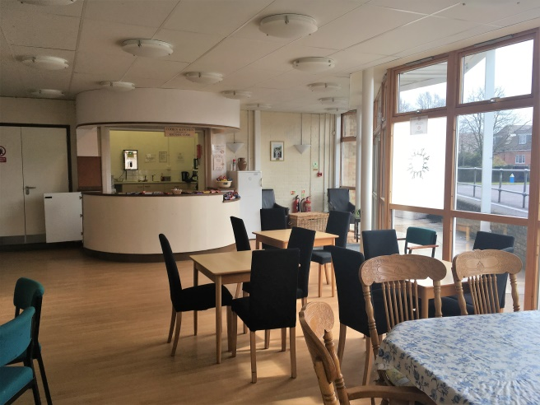
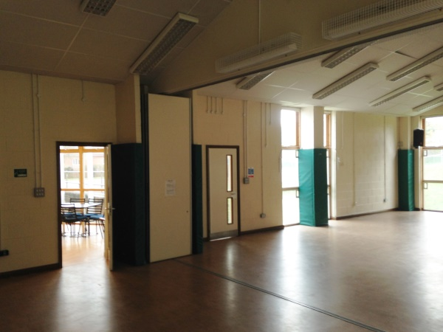

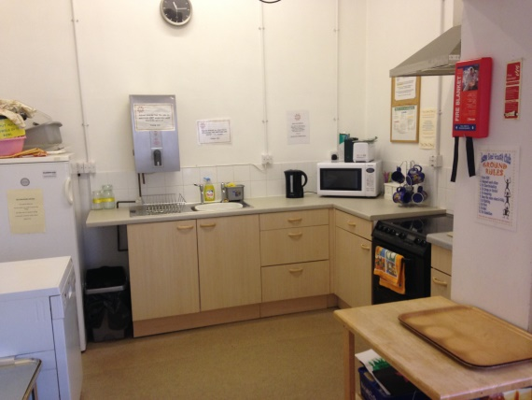
Having a party? - The Centre is so versatile and can be used for many different events/celebrations, we are very competitively priced, offering discounts to Lane End residents. Pop into the Centre or call anytime to check availability and prices for private hire. Quote Clarionoffer to get 10% off bookings confirmed and paid for by February 2019.

Please add ‘Lane End Youth & Community Centre’ on Facebook, ask to join the group and you will become one of the first to find out about all our latest events! Also check out our website at leycc.co.uk

Lane End Youth & Community Centre, Edmonds Road, Lane End, High Wycombe, HP14 3EJ

T: 01494 883878 M: 07932 326046 E: leycc@hotmail.co.uk

