Lane End Youth & Community Centre

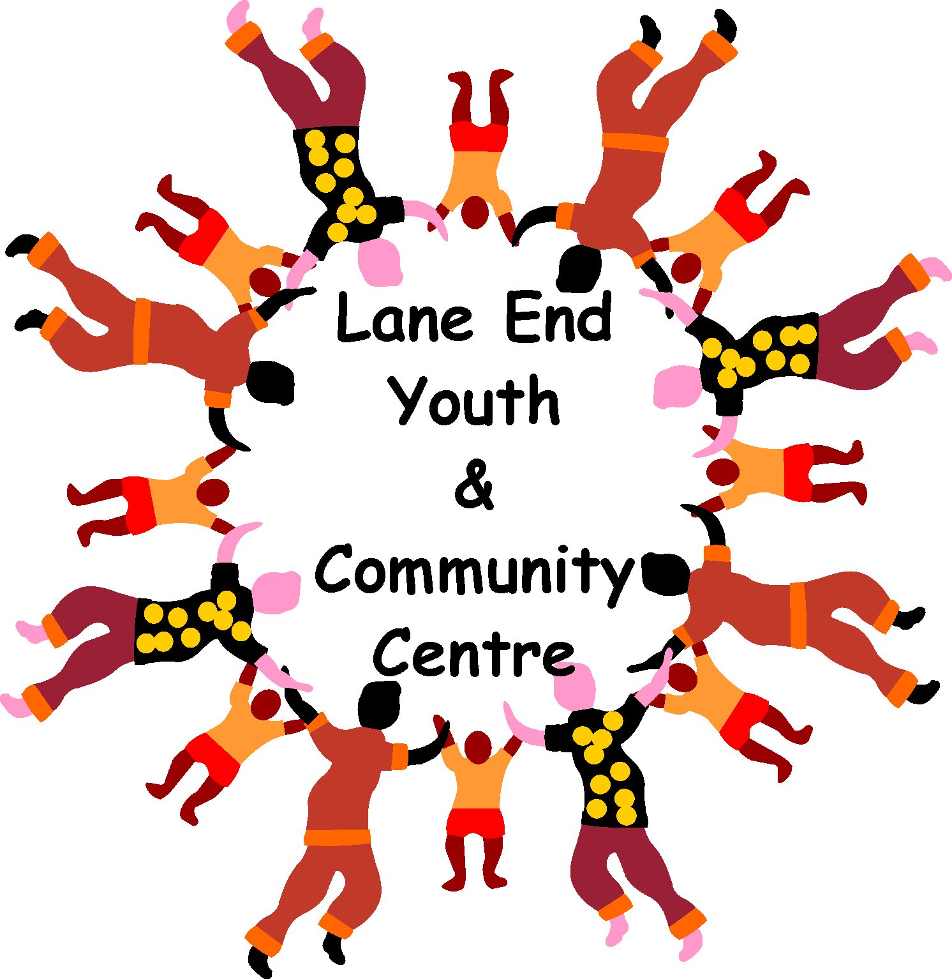

Charity Number: 1101360

www.leycc.co.uk

Have you visited the Centre?
Do you know what great facilities we offer?
Take a look at what is right on your doorstep ………..
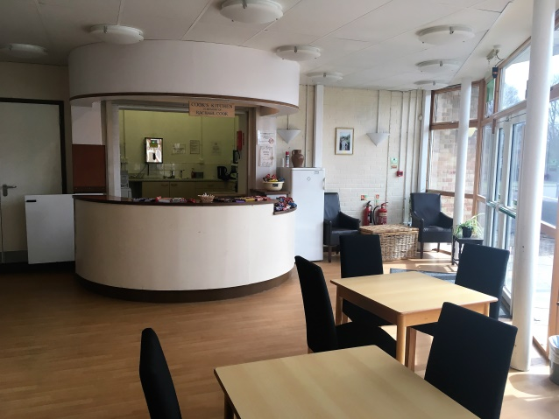
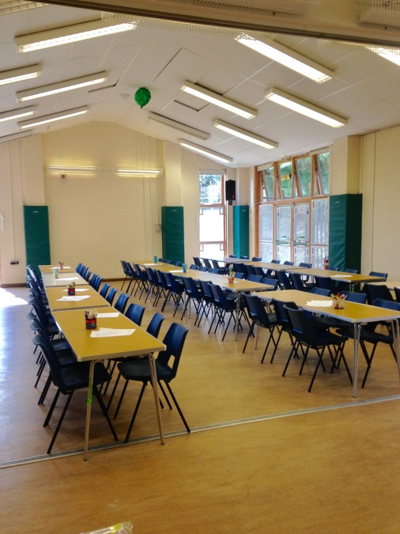
Birthday party

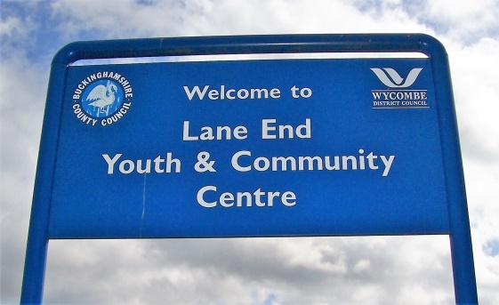

Coffee with friends

Exercise/fitness
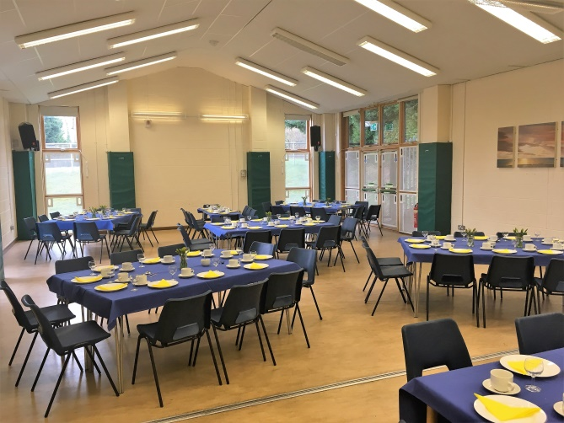
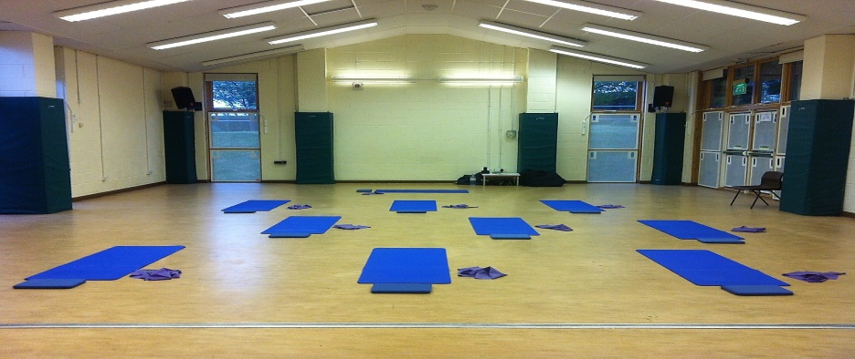

Sit down meal

Christening
Wedding

We can offer a very modern, versatile building to suit your needs, whether it’s to run an exercise class, art workshop, coffee/book club or to hire us for a celebration. **Discounts offered to Lane End residents for weekend party hire. **
Tuesday and Wednesday evenings are now available for a regular hirer, maybe you run a fitness class or singing club and need a venue, come and see what we can offer.
Email leycc@hotmail.co.uk or telephone 01494 883878 for more details.
We currently have vacancies on our committee and would love to hear from anyone who would like to be a little involved in their community without having to commit to hours each week/month. If you would like to be part of the very small team that organise events a couple of times a year or even help with weekly sessions, such as coffee, lunch or computer club (your help can be as little or big as you chose) then please give Emma a ring on 01494 883878.

DATES FOR YOUR DIARY:-
- YOUTH CLUB CHANGE OF DAY/HOURS Since April the Junior Youth Club has been moved from Tuesday evenings to WEDNESDAY teatime, the session runs 3.30 – 5.30pm for Primary School children age 8-11yrs old.
- Kings and Queens of pop disco night for the over 50’s - organised by DJ Bruce on SATURDAY 23rd JUNE from 7.30pm disco, raffle and party games! Bring your own drinks and nibbles £7 per person. Tickets available from the Community Centre.
- Summer holiday Playscheme
Week one - Monday 6th – Wednesday 8th August 2018
Week two – Monday 13th August – Wednesday 15th August 2018
10am – 3pm for children 6yrs plus, £12 per day (siblings £10) Places are going fast, so book yours in now!
- 80’s fancy dress Karaoke night – Saturday 11th August 2018 kicks off at 7.30pm. Get your florescent tutu’s, shell suits, hair crimpers, and leg warmers ready for our 1980’s themed karaoke night! Tickets cost £10 each which includes a light buffet. Bring your own drinks and some money for a raffle! Tickets available from the Centre office and the Gateway Barber Shop in the village.

Don’t forget to add ‘Lane End Youth & Community Centre’ on Facebook, ask to join the group and you will become one of the first to find out about all our latest events!

Lane End Youth & Community Centre, Edmonds Road, Lane End, High Wycombe, HP14 3EJ

T: 01494 883878 M: 07932 326046 E: leycc@hotmail.co.uk

