Lane End Youth & Community Centre

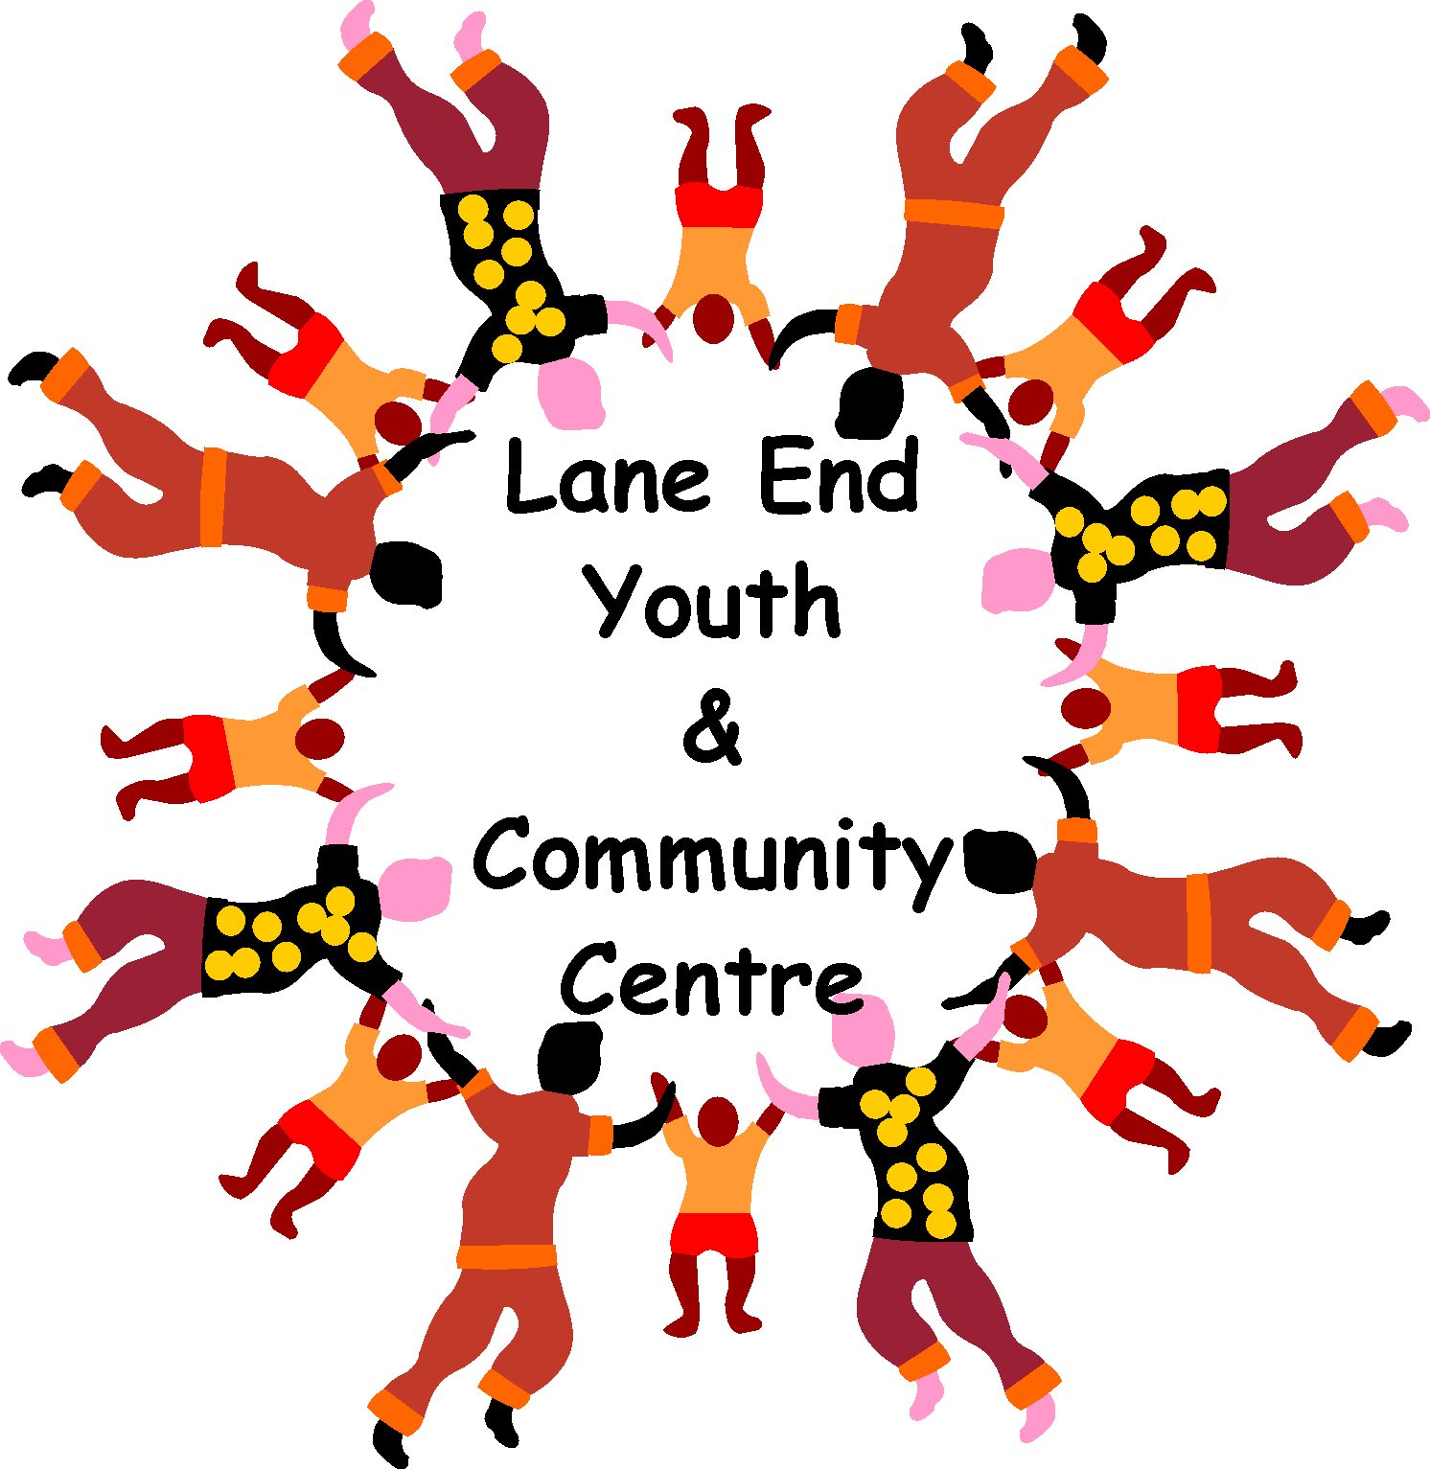

Charity Number: 1101360

www.leycc.co.uk

Report by Emma Savory
WHAT’S ON IN 2017

2016 was such a successful year for LEYCC’s playschemes, we ran child-focussed workshops during Easter, Summer, October and at Christmas. Have a look at the photos …………….
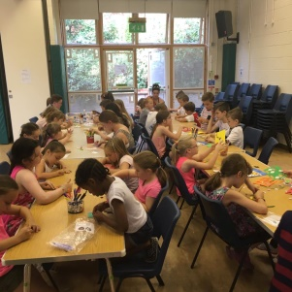
B
A
K
I
N
G

Biscuit decorating
ARTS & CRAFTS
Baking mince
pies
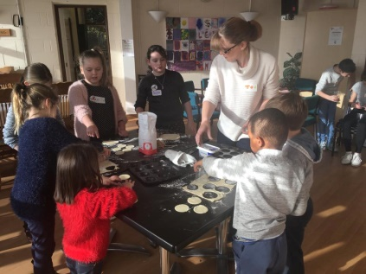

We even had a travelling ZOO visit us where the children got to meet some animals!

EASTER 2017 Playscheme dates –
Wednesday 5th and 12th April 2017, 10am until 3pm
6 yrs. plus - £10 per child per day
Art, crafts, cooking, sports, games, stories and soooo much more!
Places go fast, so book yours now!

Thursday Lunch Club 12 – 1.30pm
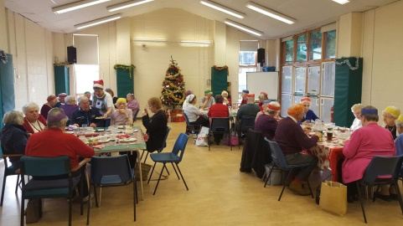
What a fabulous Christmas lunch day we had on the 21st December 2016, we enjoyed arrival drinks, a delicious full Christmas dinner and pudding, followed by mince pies and tea/coffee. Some fun entertainment was organised by Val and Sylvia and a great raffle. Thank you to the volunteers for helping on the day, and of course thanks to all the regulars who attend lunch club each week. Maybe you would like to join us this year? Every Thursday we welcome you into the Centre for a 2 course cooked dinner with tea or coffee for £5.50. We currently have a small group of volunteers who take turns each week to provide approximately 20 people a delicious hot meal. We are always looking for people who can help, cook or serve at this club, maybe you have 2 hours a month you can spare to help out, if so please get in touch.

Computer Club – Every Thursday 11.30am – 2.00pm
This club is run by Charmain who is on hand to help with any IT i.e. computer/tablet/iPad problems you may have. It is a ‘drop in’ session with no formal structure. If you need help with setting up/retrieving emails, internet security, downloading and editing photos or any IT query, Charmain will be on hand to point you in the right direction! This is a FREE facility but we do appreciate a donation if you can afford it when you visit, pop in with your laptop or use one of ours, everyone is welcome!
Coffee Shop – Mondays 10.30am – 12noon
Do you want to meet new local people? Then come along to our coffee morning, every Monday at 10am. All ages welcome.

Children’s Bingo –,
FEB HALF TERM - Prize Bingo on TUESDAY 14th FEBRUARY 2017
EASTER EGG bingo on MONDAY 10th APRIL 2017
Both sessions start at 1.30pm, with tickets on sale at £2.50 per child at 1pm. Don’t forget the tuck shop will be selling all your favourite sweets and drinks. No need to book just pop along!

A fun entertaining evening of mediumship - SATURDAY 13th MAY 2017
Once again Wonky Wand are proud to announce an evening with Natalie the medium at Lane End Youth & Community Centre. Doors open at 7.30pm. Licensed Bar available. Tickets are £12 each and can be purchased at www.ticketsource.co.uk/date/334198

DISCO NIGHT-
50’s & 60’s themed disco – SAT 17th JUNE, bring your own drink and nibbles, Raffle, tickets £7.00 per person

Having a party? - The Centre is so versatile and can be used for many different events/
celebrations, we are very competitively priced, offering discounts to Lane End residents. Pop into the Centre or call anytime to check availability and prices for private hire

Please add ‘Lane End Youth & Community Centre’ on Facebook, ask to join the group and you will become one of the first to find out about all our latest events! Don’t forget to check out our wonderful website too www.leyc.co.uk

Remember the Centre is here for the community, please support it!

Lane End Youth & Community Centre, Edmonds Road, Lane End, High Wycombe, HP14 3EJ

T: 01494 883878 M: 07932 326046 E: leycc@hotmail.co.uk

HALF PAGE ADVERT...................

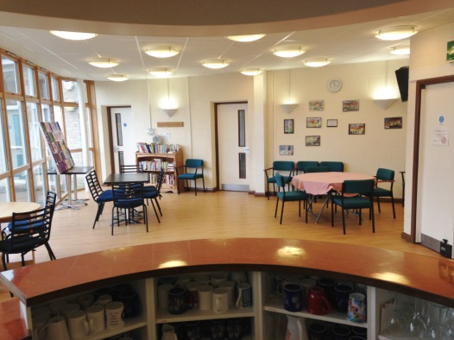
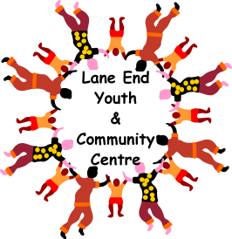
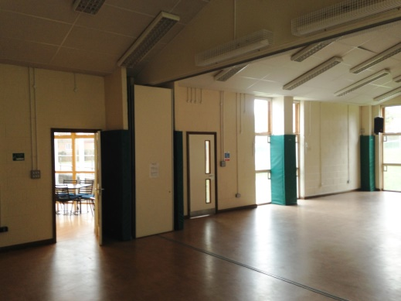

Can you help?

The Community Centre is a registered charity that opened in 2004, over those years we have offered many services. We rely on the residents of Lane End and surrounding areas to use our facilities as much as possible.

Currently a very small group of volunteers form the committee. Our aim for 2017 is to continue to provide the wonderful services plus hold some new fundraising events, however we are unable to host these without more volunteers on the committee. Maybe you could spare a couple of hours to help organise an event? If you don’t have time to spare for helping with events, maybe you can attend an evening meeting once every 8 weeks? You may even consider filling the vacancy of secretary for the committee (it isn’t as scary as it sounds!) you just need to be able to take notes and type up the minutes.

We welcome anyone who is interested to find out more to join our next committee meeting, call Emma on 01494 883878 or email leycc@hotmail.co.uk for more information.

Lane End Youth & Community Centre, Edmonds Road, Lane End, High Wycombe, HP14 3EJ

T: 01494 883878 M: 07932 326046 E: leycc@hotmail.co.uk

