Lane End Youth & Community Centre

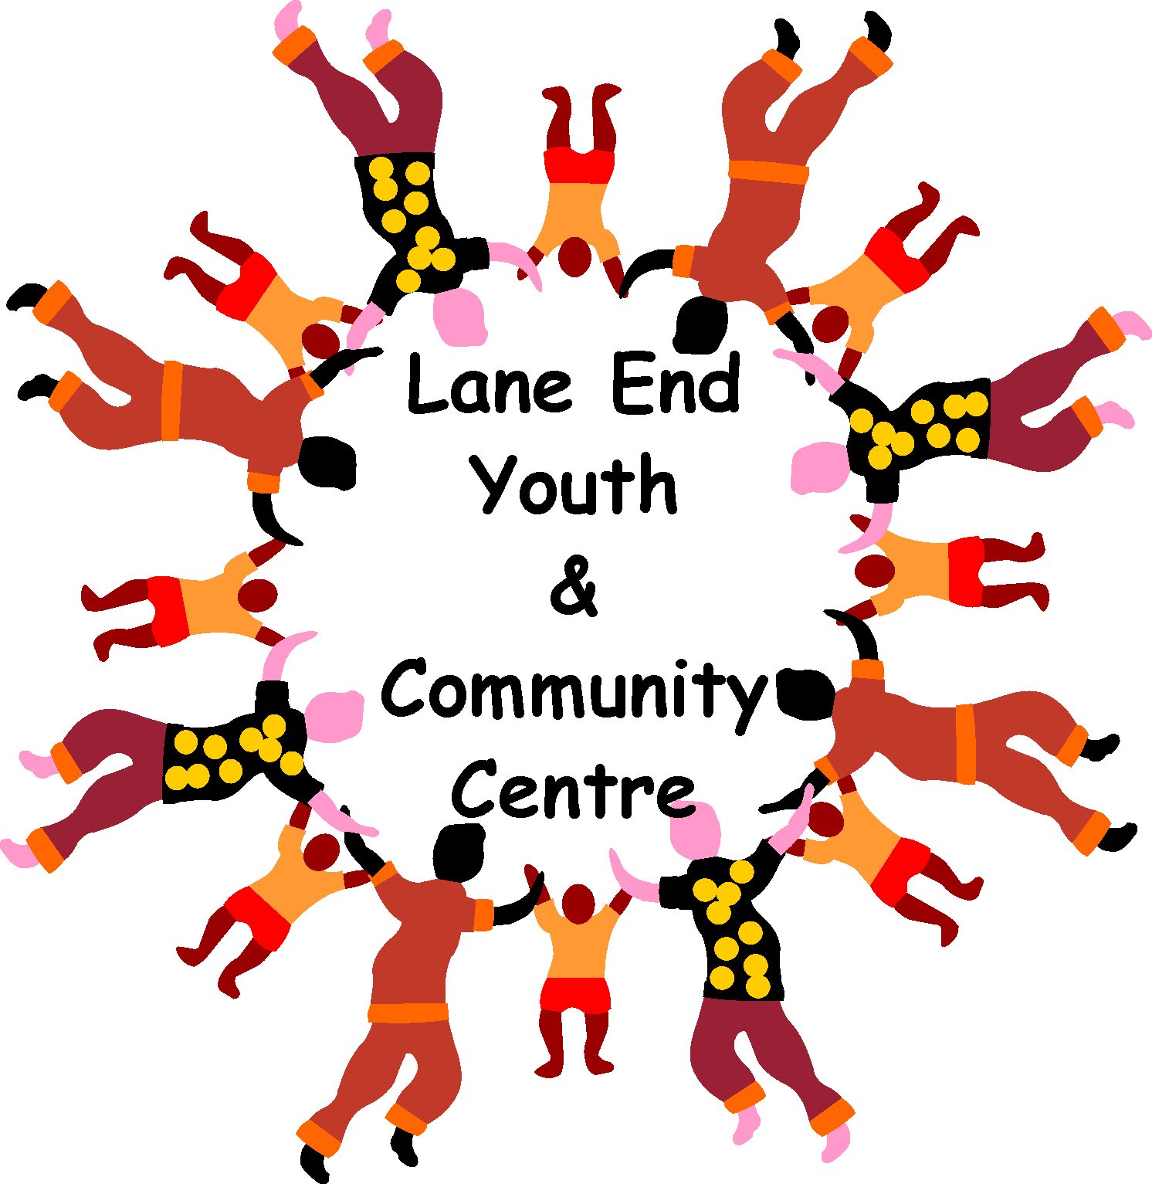

Charity Number: 1101360

www.leycc.co.uk

Report by Emma Savory

We had so much fun during 2018 at Playscheme, look …….
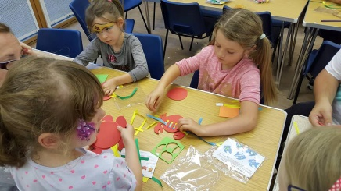
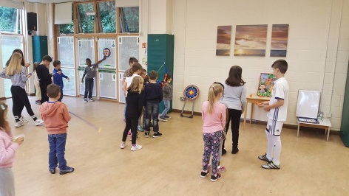

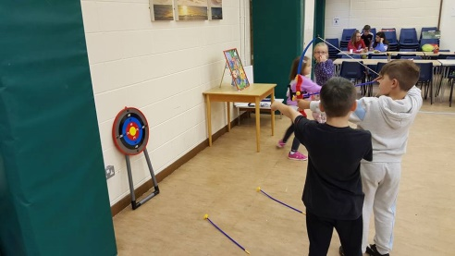
ARTS & CRAFTS
Team sports!

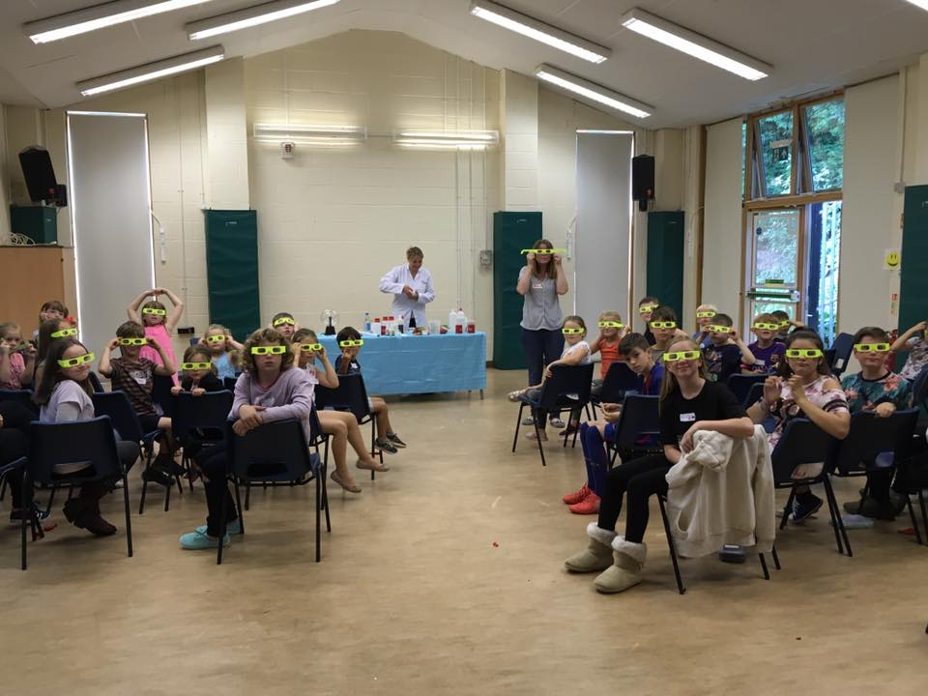

Come join the fun at Playscheme 2018, dates:
MAD SCIENCE DAY!
FEB HALF TERM – Tuesday 13th Feb
EASTER HOLS – Wed 7th & Wed 14th April
Places available for over 6 yr olds
£12 per child, £10 each sibling
10am – 3pm
Book your child a place now email: leycc@hotmail.co.uk

Thursday Lunch Club 12 – 1.30pm
What a fabulous Christmas lunch day we had on the 21st December 2017, we enjoyed arrival drinks, a delicious full Christmas dinner and pudding, followed by mince pies and tea/coffee. Some fun entertainment was organised by Val and Sylvia and a great raffle. Thank you to the volunteers for helping on the day, and of course thanks to all the regulars who attend lunch club each week. Maybe you would like to join us this year? Every Thursday we welcome you into the Centre for a 2 course cooked dinner with tea or coffee for £5.50. We currently have a small group of volunteers who take turns each week to provide approximately 20 people a delicious hot meal. We are always looking for people who can help, cook or serve at this club, maybe you have 2 hours a month you can spare to help out? If so please get in touch.

Wednesday evening Hire – We currently have a Wednesday evening available for regular hire, do you run a class, workshop, club and need a local venue to hire? We could be the perfect place. Email leycc@hotmail.co.uk for details.

Computer Club – Every Thursday 11.30am – 2.00pm
This club is run by Charmain who is on hand to help with any IT i.e. computer/tablet/iPad problems you may have. It is a ‘drop in’ session with no formal structure. If you need help with setting up/retrieving emails, internet security, downloading and editing photos or any IT query, Charmain will be on hand to point you in the right direction! This is a FREE facility but we do appreciate a donation if you can afford it when you visit, pop in with your laptop or use one of ours, everyone is welcome!
Coffee Shop – Mondays 10.30am – 12noon
Do you want to meet new local people? Then come along to our coffee morning, every Monday at 10am. All ages welcome.

Children’s Bingo –,
EASTER EGG PRIZE bingo on TUESDAY 3RD APRIL
Starts at 1.30pm, with tickets on sale at £2.50 per child at 1pm. Don’t forget the tuck shop will be selling all your favourite sweets and drinks. No need to book just pop along!

BEACH PARTY THEMED DISCO NIGHTFOR THE OVER 50’S -
Dreaming of hot sunny weather? The join DJ Bruce for his Beach themed disco – SAT 17th FEB, bring your own drink and nibbles, Raffle, tickets £7.00 per person

Afternoon tea with a performance from the
Aca-holics
You are invited to an afternoon tea party on Sunday 25th March 2 – 5pm for a delicious feast of sandwiches and cakes with a performance from the fabulous barbershop quartet – Aca-holics. Booking is required, tickets cost £8 per person.

Having a party? - The Centre is so versatile and can be used for many different events/
Celebrations. We are very competitively priced, offering discounts to Lane End residents. Pop into the Centre or call anytime to check availability and prices for private hire

Please add ‘Lane End Youth & Community Centre’ on Facebook, ask to join the group and you will become one of the first to find out about all our latest events! Don’t forget to check out our wonderful website too www.leycc.co.uk

Remember the Centre is here for the community, please support it!

Lane End Youth & Community Centre, Edmonds Road, Lane End, High Wycombe, HP14 3EJ

T: 01494 883878 M: 07932 326046 E: leycc@hotmail.co.uk

